ML project
https://www.kaggle.com/datasets/alexteboul/diabetes-health-indicators-dataset
https://www.kaggle.com/datasets/mathchi/diabetes-data-set?resource=download
https://data.mendeley.com/datasets/m8cgwxs9s6/2

1. Pima Dataset:

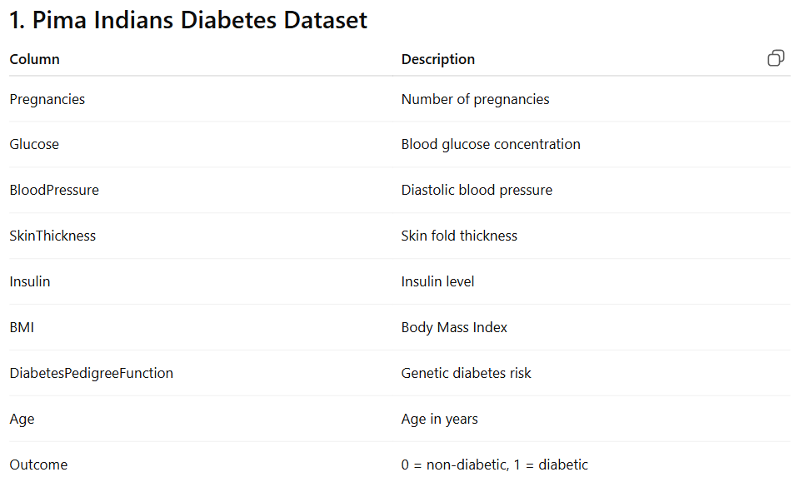

2. BRFSS Dataset:

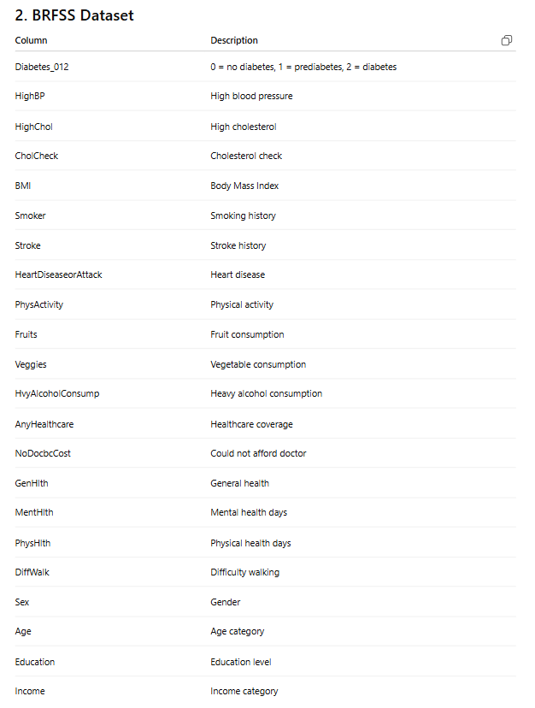
3. DiaBD_A Bangladesh Dataset:
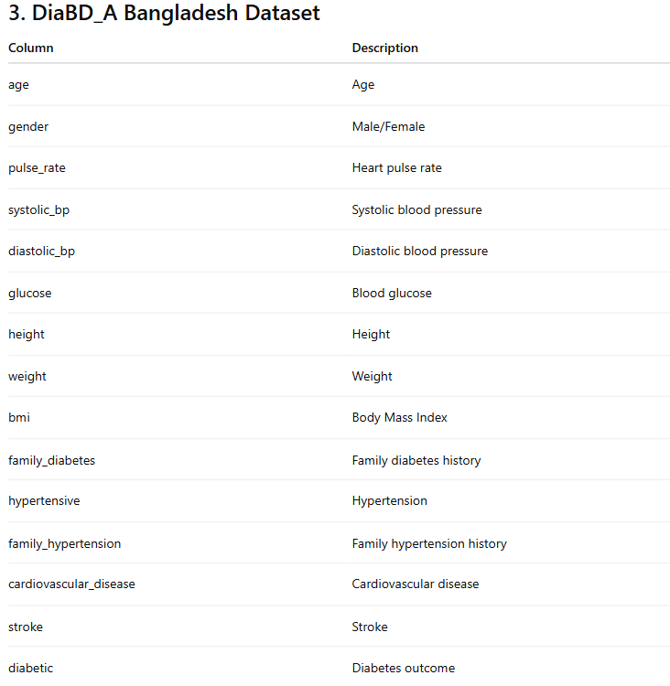

Find common columns:

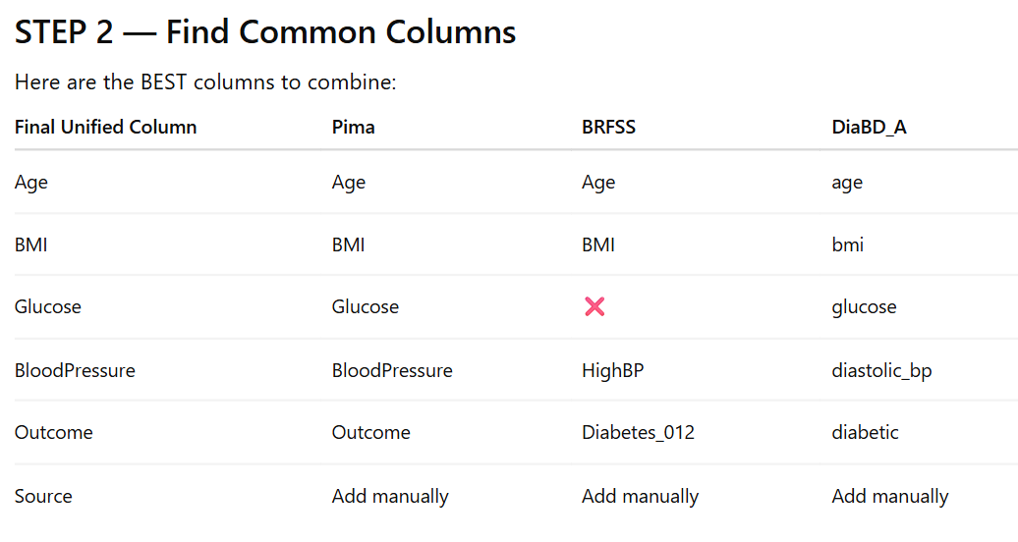
Challenges in Dataset Integration and Preprocessing
